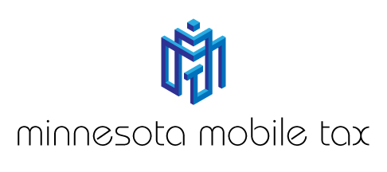

Minnesota Mobile Tax Customer Referral Form

Receive a $10 discount for referring a new customer to Minnesota Mobile Tax.

The person you referred receives a $10 discount as well.

Your Name ____________________ Their Name ____________________
Your Phone ____________________ Their Phone ____________________

Disclaimer: Discount to be given at time of tax preparation or as a rebate check

NO LIMIT: Refer as many people as you wish!

